W**EEKLY PROGRESS REPORT**

BY ANURAG SINGH

MUSIC PLAYER APP

* DATE:31/7/23
* PROJECT OVERVIEW:

The goal of this project is to develop a music player app for android that allows users to play audio files, create playlists, manage their music library, and provide a smooth and intuitive user experience.

* Accomplishments this Week:

1. Understanding the project objectives.
2. Understanding the app's core features and functionality, including audio playback, playlist creation, and library management.
3. Learning about the Scroll View (Horizontal and Vertical) that will help in enhancement of the interface view .
4. Learning about the scroll view and Recycler view that will help in the enhancement of the interface view .
5. Fixing up the volume Seek Bar.
6. Implementation of Remote data source that will help to play music through online data source.

* IMPLEMENTATION OF REMOTE DATA SOURCE THROUGH CODE

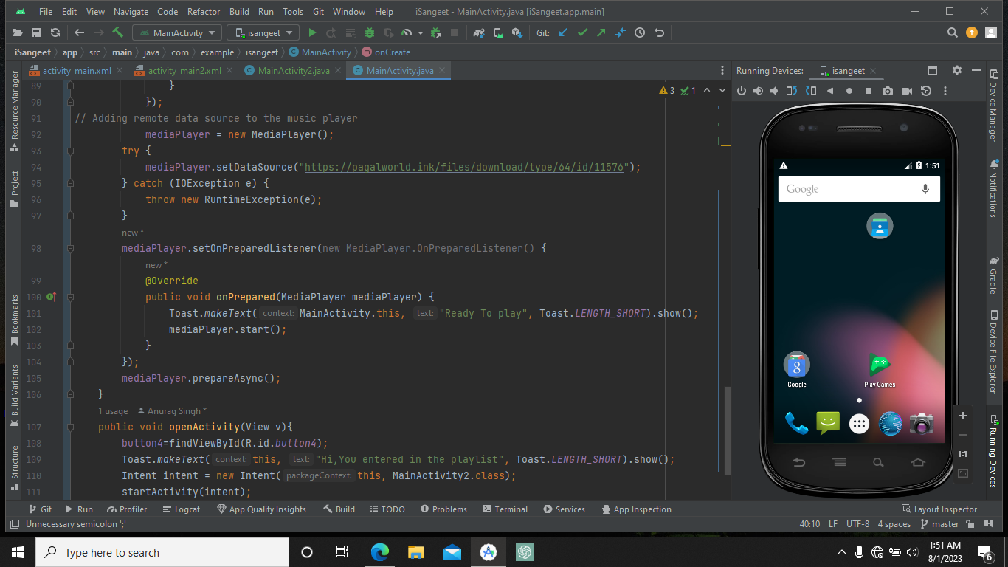

* 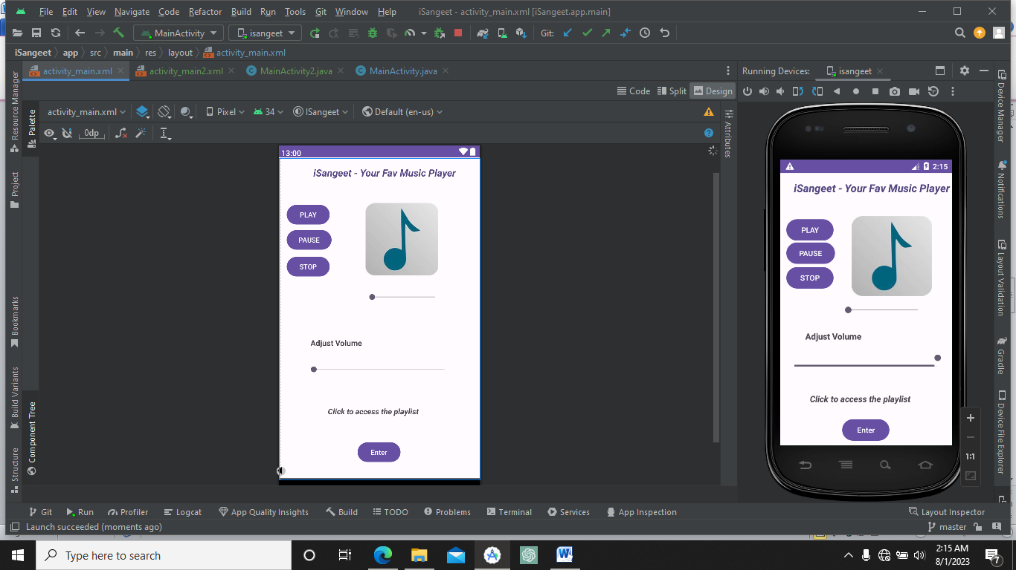
* **Setting up the surface View in the second view of the app.**

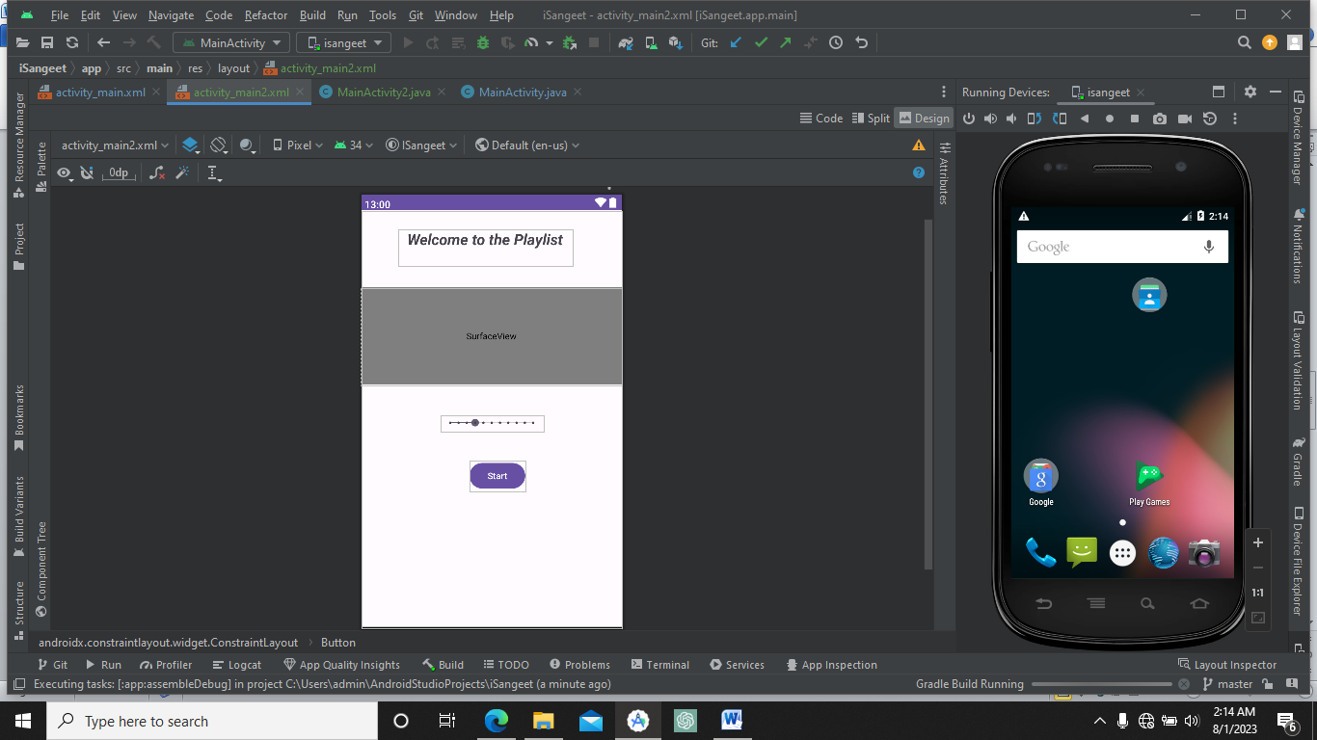

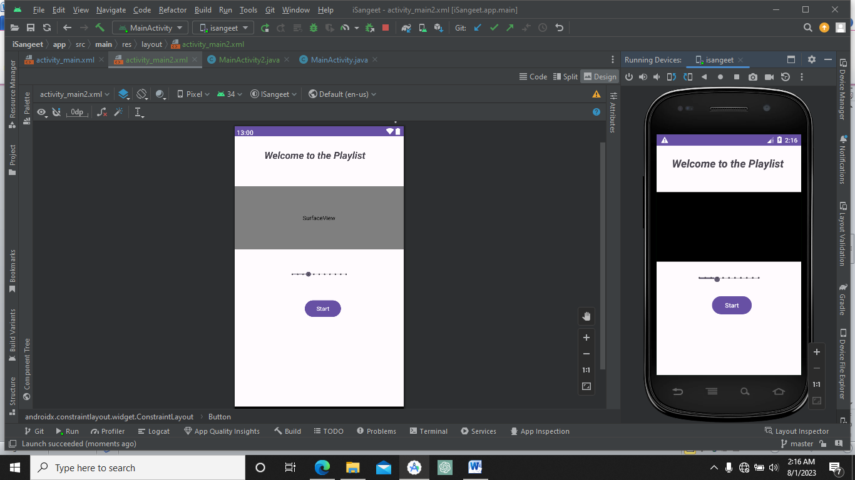

* **Setting up the Seekbar in music player**

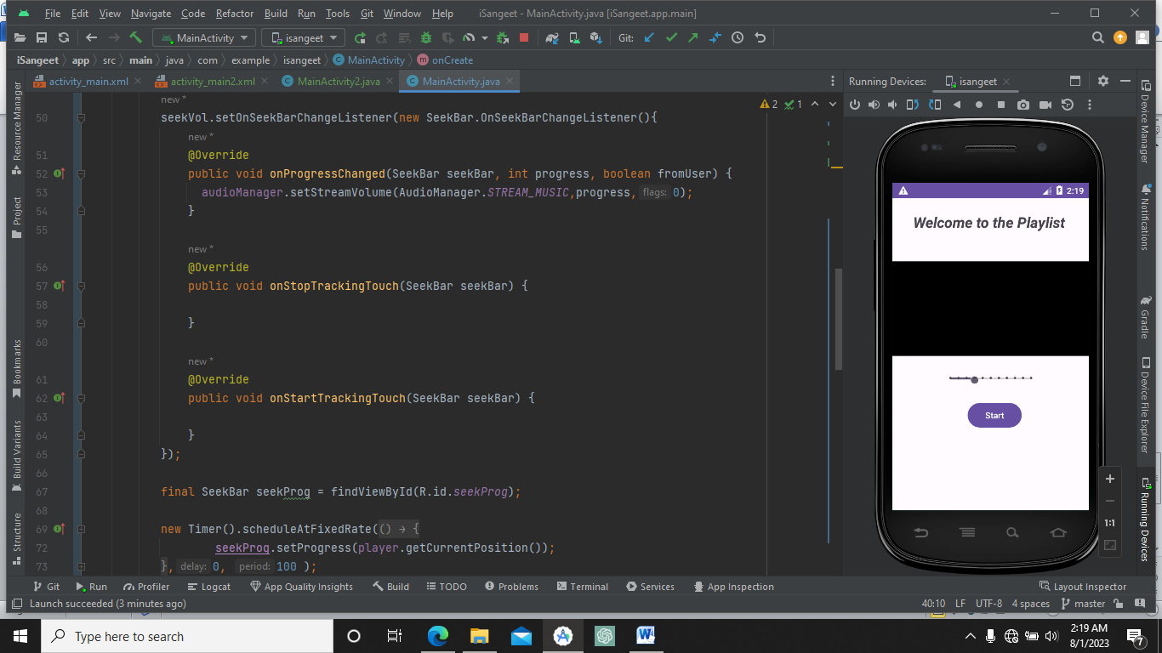

* **Challenges Faced:**

1. Faced while learning and implementing of surface view.
2. Implementing of remote data source.

* **Next Week Objective:**

1. Database Management in isangeet app.
2. Provide functionality to efficient web music.
3. Implementing functionality to its second screen interface.

Git hub link - [anuragsingh-003/iSangeet (github.com)](https://github.com/anuragsingh-003/iSangeet)